BREATHE BETTER & SLEEP BETTER EVERY NIGHT, WAKE UP REFRESHED EVERY DAY!!!
Snoreben© is a re-usable split nasal device and an effective solution for everyone who has nasal disorders such as: alar collapsed (collapsed nostrils), deviated septum, scarred and narrow nostrils and may suffer from chronic snoring caused by the blockage of the nasal cavities whilst asleep.
Snoreben© will comfortably and effectively hold nasal passages open whilst asleep and will allow everyone to breathe freely through the nose - instead of through the mouth -preventing chronic snoring.
Snoreben© is especially designed to ensure everyone will receive a good quality sleep, carry out activities with a clear mind and enjoy a happy and healthier lifestyle.
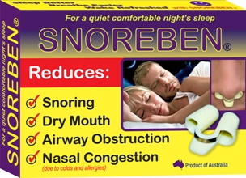 | 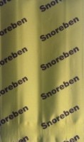  INNER PACK |  | 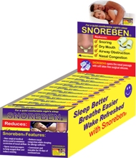 | 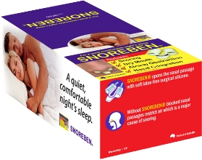

Product Features
*Effectively helps in preventing snoring, dry mouth and nasal congestion due to colds,
*Registered as a Medical Device Class 1 in South Pacific, South East Asia, China, North America & Middle East,
*Recommended for anyone with nasal breathing difficulties,
*Suitable for anyone (12yo +), especially designed with a retaining clip to safely hold the device in nasal cavities whilst the device is used,
*Continuously re-usable and easy to clean and maintain,
*100% latex free and skin allergy free, opens nasal cavities very well,
*Comfortable fit and gentle to the skin,
*Manufactured from high-quality soft medical grade materials.
RECOMMENDED RETAIL PRICE: $24.95
For wholesale, please see us at Trading Outlets or Contact Us pages.

